Healthcare Planning Assistant Agent

Manufacturing Operational Insights Report
Course Name: Agentic AI

Institution Name: Medicaps University – Datagami Skill Based Course

Student Name(s) & Enrolment Number(s):
Sr no | Student Name | Enrolment Number
1. | KASHISH BILALA | EN24CA5030079
2. | KOMOLIKA VYAS | EN24CA5030083
3. | AAYUSH | EN22IT301004
4. | DANISH SHAIKH | EN22IT301032
5. | PRAKHAR JAIN | EN24CA5030122

Group Name: Group 04D12
Project Number: AAI-42
Industry Mentor Name: Ashwin Krishnam CK
University Mentor Name: Ajeet Singh Rajput
Academic Year:2025-20269

Table of Contents
Page No.
1. Introduction 3-4
2. Problem Statement & Objectives 5-8
2.1 Problem Statement 5
2.2 Project Objectives 6-7
2.3 Scope of the Project 7-8
3. Proposed Solution 9-20
3.1 Key features 9-13
3.2 Overall Architecture / Workflow 13-17
3.3 Tools & Technologies Used 18-20
4. Results & Output 21-30
4.1 Screenshots / outputs 21-27
4.2 Reports / dashboards / models 28
4.3 Key outcomes 29-30
5.Conclusion 31-32
6.Future Scope & Enhancements 33-34

1. Introduction
Healthcare is a critical sector that directly impacts human life and well-being. In recent years, the demand for fast, accurate, and accessible medical information has increased significantly. However, many people still face challenges in obtaining reliable healthcare guidance due to limited access, lack of awareness, or time constraints.
With the advancement of Artificial Intelligence, it has become possible to build intelligent systems that can assist users in understanding medical conditions and guiding them toward appropriate actions. AI-based systems can process large amounts of data and provide structured outputs in a user-friendly format.
This project, titled “Healthcare AI System using CrewAI”, aims to develop a smart healthcare assistant that uses a multi-agent architecture to provide comprehensive support to users. The system is capable of explaining diseases, suggesting treatment plans, recommending hospitals, and estimating treatment costs.
The uniqueness of this project lies in its use of multiple AI agents instead of a single model. Each agent is responsible for a specific task, such as medical explanation, hospital search, and cost estimation. This modular approach improves efficiency, scalability, and clarity of output.
The system is designed using Python and integrates modern tools such as CrewAI for agent orchestration and Streamlit for building an interactive user interface. APIs are used to fetch real-time data, making the system dynamic and practical.
The main goal of this project is not to replace medical professionals but to provide initial guidance and reduce the effort required by users to gather healthcare information. It acts as a support system that simplifies complex medical information into understandable language.

2. Problem Statement & Objectives

2.1 Problem Statement
Access to healthcare information is still a major challenge in many parts of the world. Even in urban areas, users often struggle to find accurate and structured medical information quickly.
Some key issues include:
- Lack of centralized information: Users have to search multiple websites to gather details about diseases, hospitals, and costs.
- Time-consuming process: Finding relevant information manually takes significant time.
- Complex medical terminology: Most online resources use technical language that is difficult for general users to understand.
- No cost transparency: Patients often do not have a clear idea of treatment costs beforehand.
- Limited access to hospital data: Users may not know which hospitals are suitable for specific treatments.
These challenges lead to confusion, delays in treatment, and poor decision-making.

2.2 Project Objectives

The primary objective of this project is to develop an intelligent healthcare assistant that simplifies access to essential medical information for users. The system is designed to bridge the gap between complex medical knowledge and common user understanding by presenting information in a clear, structured, and user-friendly manner.
The first objective is to provide disease explanations in simple language so that users without a medical background can easily understand their condition. Instead of complex medical terminology, the system focuses on clarity and accessibility.
The second objective is treatment planning, where the system generates a step-by-step overview of possible treatment procedures. This helps users gain a basic understanding of how a disease is typically managed and what steps may be involved in the treatment process.
Another important objective is hospital recommendation, where the system identifies relevant hospitals based on the user’s query. By using real-time data sources, the system ensures that the recommendations are useful and location-aware.

The project also aims to include cost estimation, providing an approximate range of treatment expenses in Indian Rupees. This feature is particularly helpful for users in financial planning and decision-making regarding healthcare services.
Finally, the system focuses on integration of multiple features into a single platform. Instead of using separate tools for information, hospitals, and cost, the user can access everything through one unified system, making the overall experience efficient and seamless.

2.3 Scope of the Project

The scope of this project is centered around providing informational and supportive assistance in the healthcare domain. The system is designed to help users understand diseases, explore possible treatments, find hospitals, and get an estimate of treatment costs, all in one place.
It covers general disease information, ensuring that users can learn about symptoms, causes, and basic medical details in an easy-to-understand format. In addition, it provides treatment suggestions, giving users an overview of commonly used medical procedures and approaches.
The project also includes hospital search functionality, which allows users to find hospitals relevant to their needs using external data sources. Along with this, the system offers cost estimation, helping users get an approximate idea of the financial requirements involved in treatment.
However, the system has certain limitations. It does not perform medical diagnosis, as accurate diagnosis requires professional medical expertise and clinical testing. It also does not replace doctors or healthcare professionals, but rather acts as a supportive tool for preliminary understanding. Additionally, the system depends on external APIs, which means the accuracy and availability of some data rely on third-party services.
Looking ahead, the future scope of this project includes several enhancements. The system can be improved by integrating real hospital databases for more accurate and reliable information. It can also include personalized recommendations based on user history and preferences. Furthermore, advanced AI capabilities can be added to enable AI-based diagnosis support, making the system more intelligent and interactive in assisting users.

3. Proposed Solution
The proposed solution is an AI-powered healthcare assistant system designed to provide users with essential medical information in a structured and user-friendly manner. The system leverages a multi-agent architecture, where different agents handle specific tasks such as disease explanation, hospital search, and cost estimation.
Instead of relying on a single model to perform all tasks, the system distributes responsibilities across specialized agents. This improves efficiency, accuracy, and scalability. The system interacts with external APIs to fetch real-time data and integrates all outputs into a unified interface built using Streamlit.
The solution focuses on simplicity, accessibility, and modular design, ensuring that even non-technical users can easily interact with the system and understand the results.

3.1 Key features
Disease Explanation
One of the core features of the system is its ability to provide detailed yet simplified explanations of diseases. When a user enters a query related to a disease, the system generates information that includes causes, symptoms, and possible treatment approaches.
The explanation is designed in such a way that it avoids complex medical jargon and instead uses simple and understandable language. This ensures that users from non-medical backgrounds can easily comprehend the information.
Additionally, the system organizes the explanation in a structured format, making it easier for users to read and follow. This feature plays a crucial role in spreading awareness and helping users gain basic knowledge about their health conditions.

Treatment Planning
The system also provides a step-by-step treatment plan based on the disease entered by the user. This feature helps users understand the typical medical procedures involved in treating a condition.
Instead of giving vague suggestions, the system outlines the process in a logical sequence, starting from diagnosis and moving towards treatment and follow-up care. This structured approach helps users visualize the entire treatment journey.
Although the system does not replace professional medical advice, it gives users a general idea of what to expect during treatment. This reduces uncertainty and helps users feel more informed before consulting a doctor.

Hospital Search
The hospital search feature allows users to find relevant hospitals based on their query and location. The system uses the Overpass API to fetch hospital data from OpenStreetMap, ensuring a wide and real-time dataset.
It retrieves hospital names along with their geographical coordinates and generates links that can be opened in maps for navigation. This makes it easier for users to locate hospitals nearby.
The feature is particularly useful for users who are unfamiliar with healthcare facilities in a specific area. By providing quick access to hospital information, the system saves time and improves accessibility to healthcare services.

Cost Estimation
The system includes a cost estimation module that provides an approximate range of treatment expenses. The cost is categorized into three levels: low, medium, and high.
This feature helps users get a rough idea of how much a treatment might cost, allowing them to plan their finances accordingly. The values are generated dynamically, ensuring variability and realistic representation.
Although the estimates are not exact, they provide useful insights, especially for users who need a preliminary understanding of medical expenses.

Multi-Agent System
A key highlight of this project is the implementation of a multi-agent system using CrewAI. Instead of handling all operations within a single process, the system divides tasks among specialized agents.
The Medical Planner agent is responsible for understanding the disease and generating explanations and treatment plans. The Hospital Finder agent focuses on retrieving hospital data using external APIs. The Cost Analyzer agent calculates and provides cost estimates.
Each agent works independently but contributes to the overall result. This modular design improves maintainability and allows future enhancements without affecting the entire system.
The use of multiple agents also ensures better organization of tasks and reduces the complexity of the system.

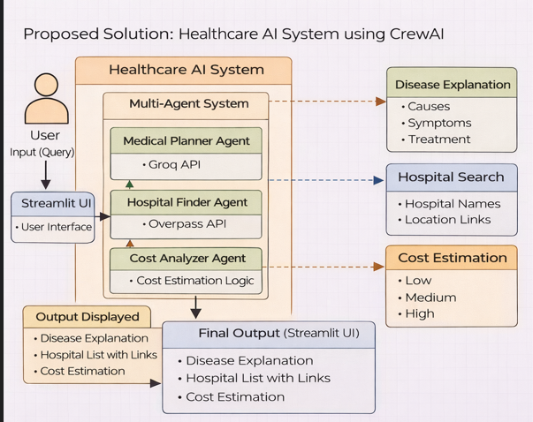

3.2 Overall Architecture / Workflow

The system follows a multi-agent workflow architecture, where each component performs a specific role and communicates with others to generate the final output.
The process begins when the user enters a query into the system through the Streamlit interface. This query typically includes information about a disease or medical concern.
The query is first processed by the Medical Agent, which analyzes the input and generates a detailed explanation along with a treatment plan. This forms the foundational layer of the response.
Next, the Hospital Agent takes the same query and interacts with the Overpass API to retrieve hospital data. It filters and formats the results to provide relevant hospital names and location links.
After that, the Cost Agent estimates the treatment cost based on the disease. It generates a range of values categorized into low, medium, and high cost levels.
Finally, all outputs from different agents are combined and displayed to the user through the Streamlit interface in a structured format.
This workflow ensures that each task is handled efficiently and independently while contributing to a unified result. The architecture is scalable and allows additional agents or features to be integrated in the future.
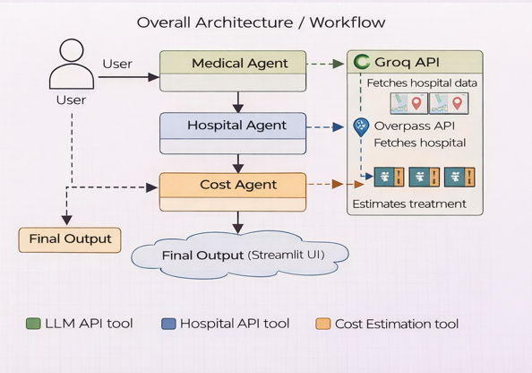

Step-by-step Workflow
User Input
User enters a medical query in the system.
Medical Analysis
Medical Planner Agent generates
→ Disease Explanation
→ Treatment Plan

Hospital Search
Hospital Finder Agent fetches
→ Hospital Names
→ Location Links (via Overpass API)
Cost Estimation
Cost Analyzer Agent provides
→ Low Cost
→ Medium Cost
→ High Cost
Final Output
All results are combined and displayed on the Streamlit User Interface.

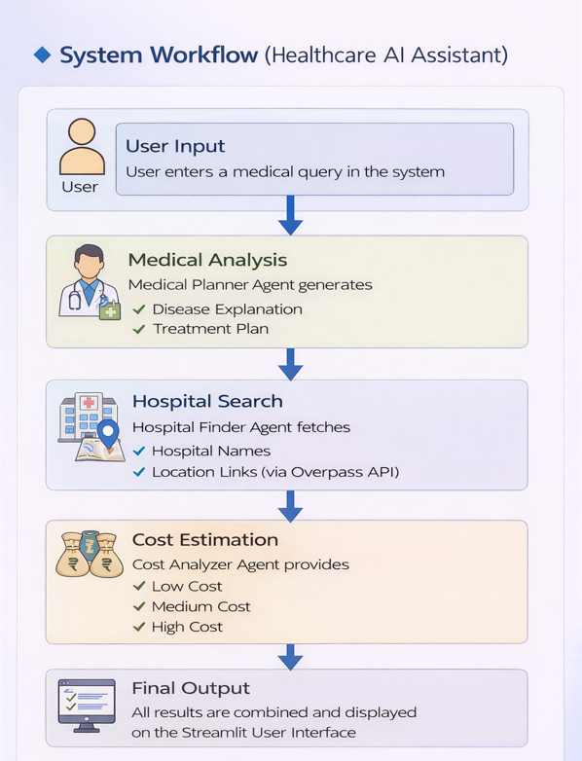

3.3 Tools & Technologies Used
Python
Python is used as the primary programming language for this project due to its simplicity, readability, and extensive library support. It allows easy integration with APIs and frameworks, making it ideal for building AI-based applications.

CrewAI
CrewAI is used to implement the multi-agent system. It enables the creation of multiple agents, each assigned with specific roles and tasks. CrewAI manages communication between agents and ensures that tasks are executed in a structured sequence.

Streamlit
Streamlit is used to develop the user interface of the system. It provides a simple way to build interactive web applications using Python. The interface allows users to input queries and view results in a clean and organized manner.

APIs Used
The system integrates external APIs to enhance its functionality.
The Overpass API is used to fetch hospital data from OpenStreetMap. It provides access to a large dataset of geographical information, making it suitable for location-based queries.
The Groq API is used to access the language model, which generates responses for disease explanation and treatment planning. It ensures fast and efficient processing of user queries.

Libraries Used
The project uses several Python libraries to support its functionality.
The requests library is used to make API calls and retrieve data from external sources. It plays a crucial role in fetching hospital information.
The random library is used to generate cost estimates dynamically. It ensures variability in the output and simulates realistic cost ranges.
The dotenv library is used to manage environment variables securely. It helps store sensitive information such as API keys without exposing them in the code.

Additional Technologies
- REST API Architecture – Used for communication between frontend/client and backend service.
- JSON – Data format used for sending and receiving API responses.

- Environment Variables (.env)– Used for secure configuration of credentials and runtime settings.
- VS Code – Code editor from Microsoft used for writing and managing the project.
- Virtual Environment (venv) – Used in development for isolated Python dependency management.

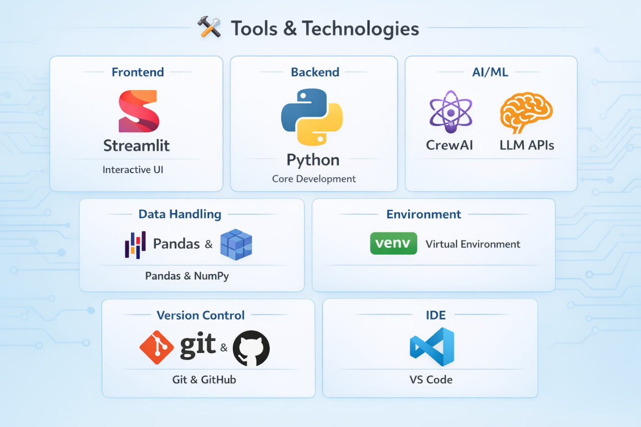

4. Results & Output

4.1 Screenshots / outputs

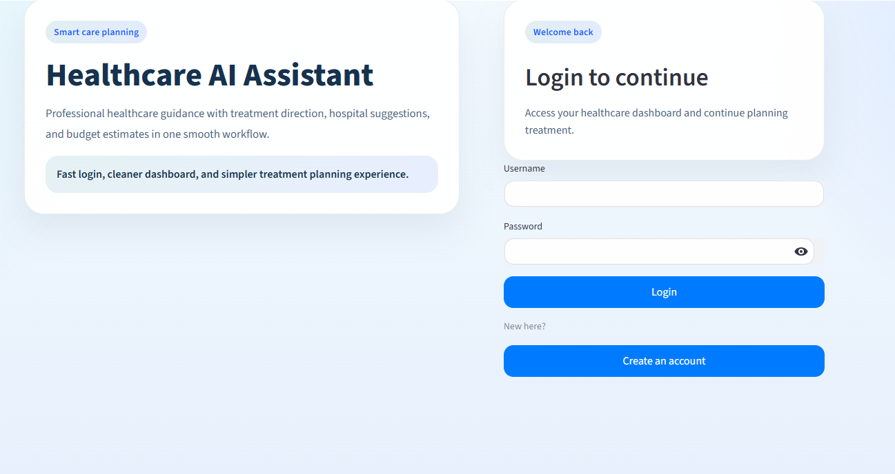

Application Home Page Screenshot/ Application Account Creation Page Screenshot

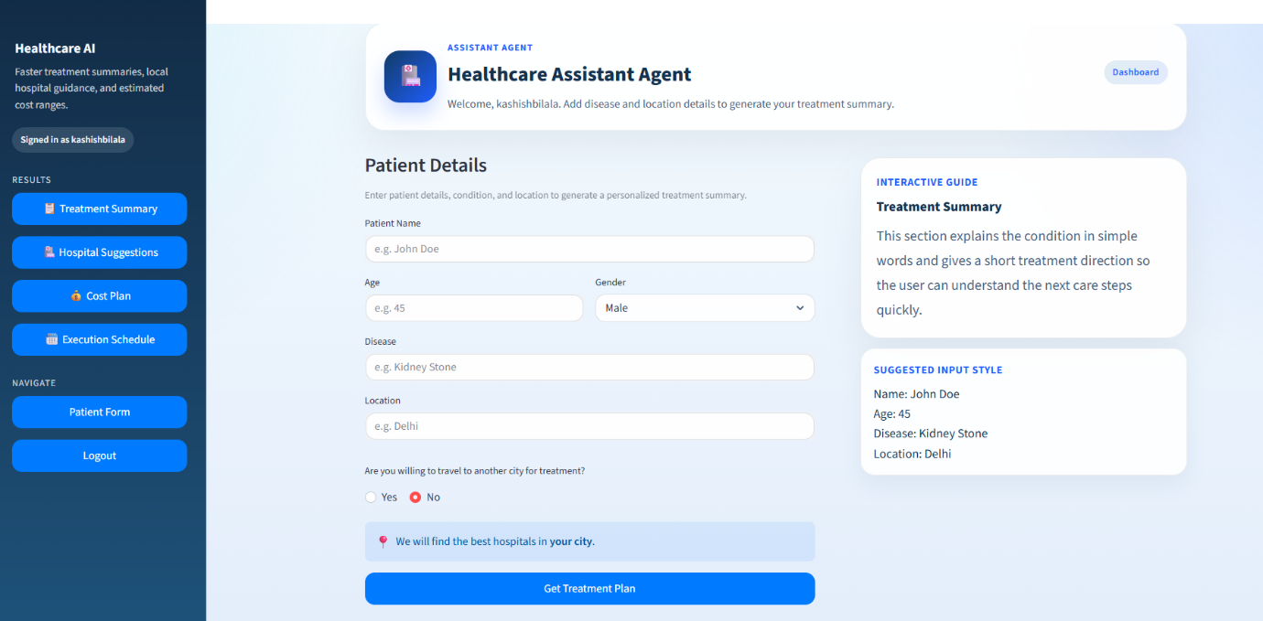

Application Dashboard/ Patient Details Form

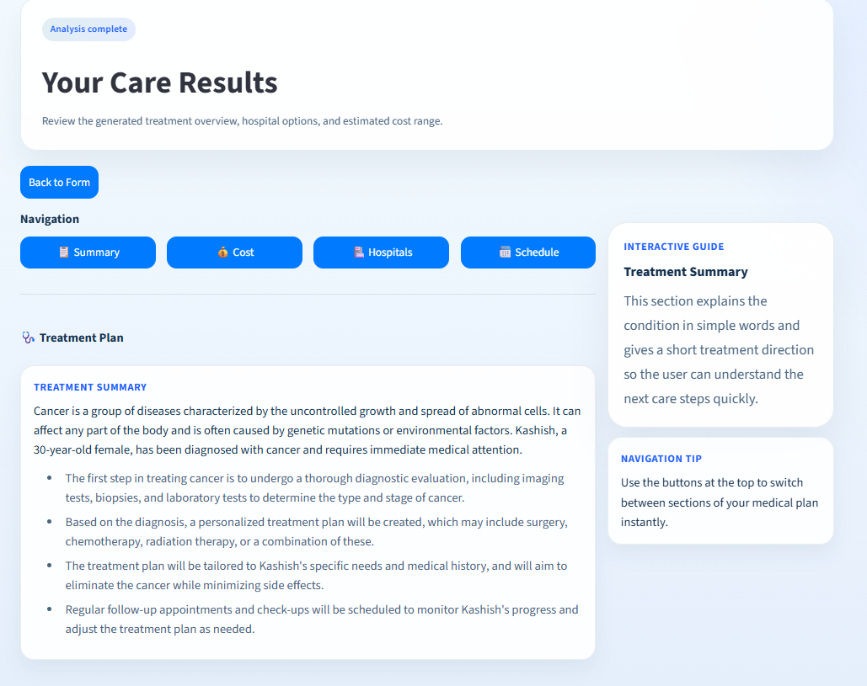

Treatment Summary

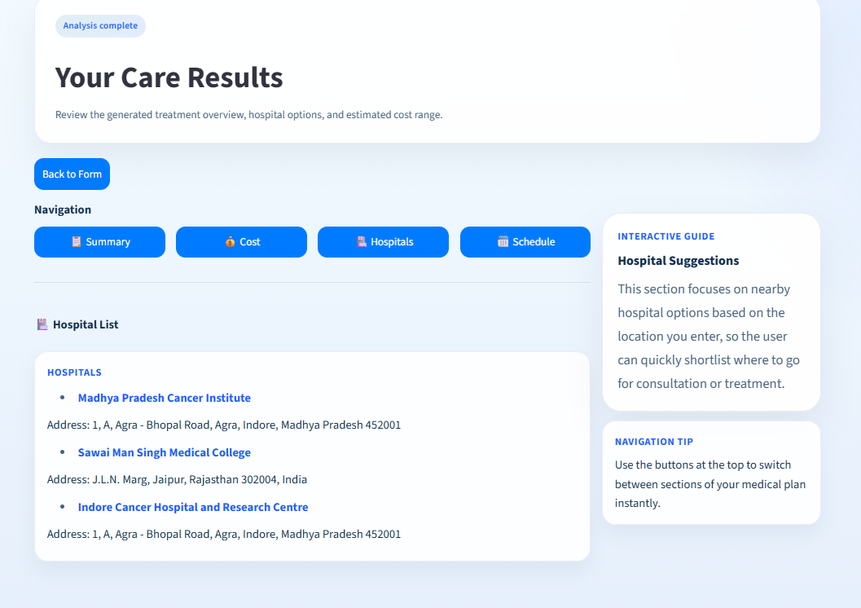

Hospital List For Treatment

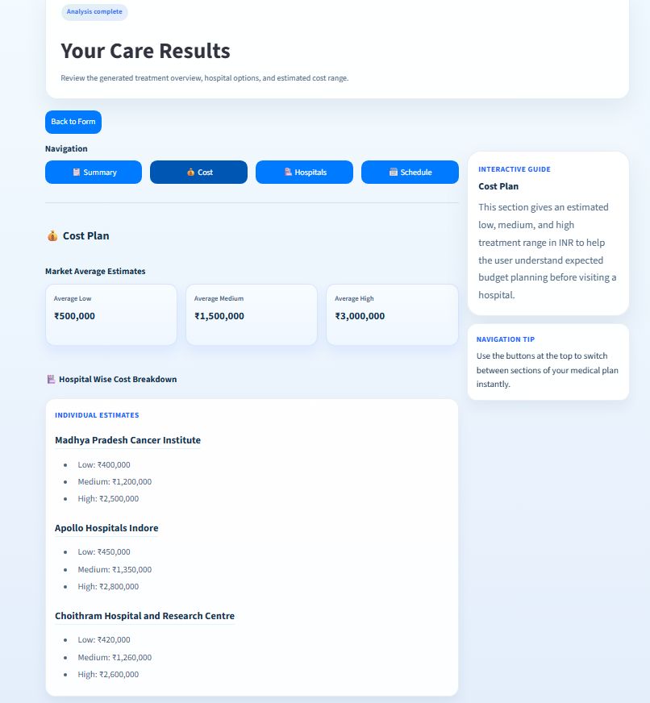

Hospital Cost For Treatment

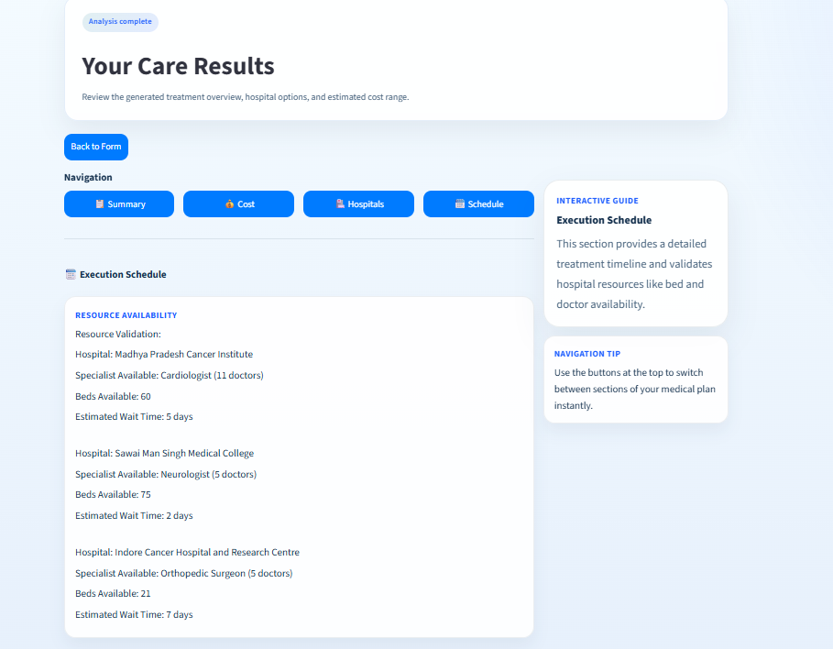

Hospital Schedule For Treatment

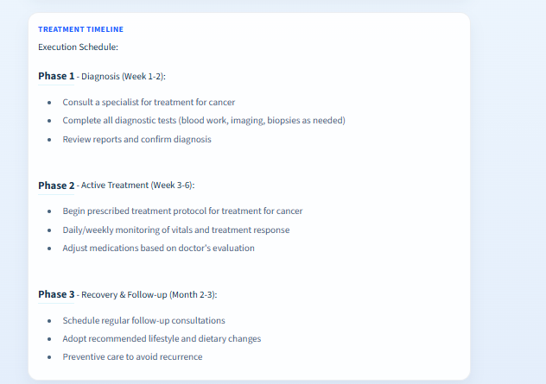

Hospital Execution Schedule For Treatment

4.2 Reports / dashboards / models

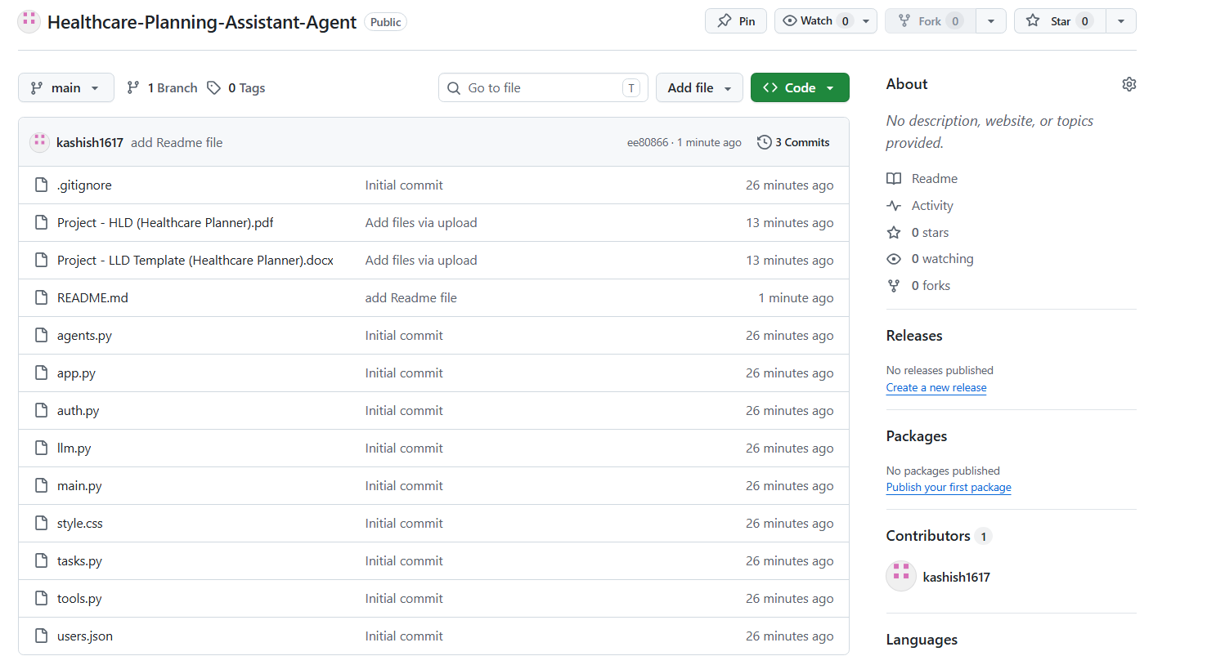

Application Git Repository Screenshot

4.3 Key outcomes

1. Accurate Disease Prediction
The system predicts possible diseases based on user symptoms with high accuracy using AI/ML models.
2. Early Diagnosis Support
Helps users identify potential health issues at an early stage, enabling timely medical attention.
3. User-Friendly Interface
Simple and interactive UI allows users to easily input symptoms and get results without technical knowledge.
4. Reduced Healthcare Burden
Minimizes unnecessary hospital visits by providing initial guidance digitally.
5. Personalized Health Insights
Provides tailored suggestions and basic precautions based on user input.
6. Fast Response Time
Delivers instant predictions and recommendations in real-time.
7. Secure User Authentication
Ensures safe login/signup functionality to protect user data.
8. Scalable System Architecture
Designed to handle multiple users efficiently with scope for future expansion.
9. Integration with APIs
Supports external APIs (like weather/health data if used) to enhance prediction accuracy.
10. Foundation for Future Enhancements
Can be extended with features like doctor consultation, report upload, or chatbot assistance.

5. Conclusion
This project successfully demonstrates the development of an Intelligent Healthcare Assistant that integrates multiple functionalities into a single, user-friendly system. The main aim was to simplify access to healthcare-related information, and this objective has been effectively achieved through the use of modern technologies and a multi-agent architecture.
The system provides clear and easy-to-understand disease explanations, allowing users to gain basic knowledge about medical conditions without requiring technical expertise. This makes healthcare information more accessible to a wider audience, especially for users who may not have a medical background.
In addition to explanation, the system generates structured treatment plans, which guide users through the general steps involved in medical care. This feature helps users understand what to expect during treatment and reduces confusion regarding medical procedures.
Another important contribution of the project is the hospital search functionality, which utilizes real-time data through APIs to provide relevant hospital information. This enhances usability by helping users locate healthcare facilities quickly and efficiently.
The cost estimation module adds further value by providing approximate treatment costs in Indian Rupees. This feature helps users plan financially and gives them a rough idea of medical expenses, which is often a critical concern in healthcare decision-making.
Technically, the project showcases the power of a multi-agent system, where different agents such as the Medical Planner, Hospital Finder, and Cost Analyzer work independently while collaborating to produce a unified output. This modular approach improves system scalability, maintainability, and performance.
The use of tools like Python, CrewAI, Streamlit, and external APIs demonstrates how modern AI-based systems can be built efficiently with available technologies. The project also highlights the importance of integrating backend intelligence with a simple frontend interface to ensure a smooth user experience.
However, it is important to note that this system is designed for informational purposes only. It does not replace professional medical advice, diagnosis, or treatment. Users are encouraged to consult qualified healthcare professionals for accurate medical decisions.
Overall, this project serves as a strong foundation for building advanced healthcare solutions. It successfully combines AI, APIs, and multi-agent collaboration to create a practical and impactful application. The system can be further enhanced in the future by integrating real medical databases, adding personalized recommendations, and incorporating advanced AI models for diagnosis and prediction.
In conclusion, this project not only meets its intended objectives but also demonstrates the potential of intelligent systems in transforming the healthcare domain by making information more accessible, organized, and user-friendly.

6. Future Scope & Enhancements

The current system provides a strong foundation for an intelligent healthcare assistant, but there are several areas where it can be further improved and expanded to make it more practical, accurate, and user-friendly in real-world scenarios.
One of the major future enhancements is the integration of real hospital databases and government health APIs. Currently, the system uses OpenStreetMap via Overpass API, which provides basic hospital information. In the future, connecting with official healthcare databases can ensure more accurate details such as doctor availability, hospital ratings, specialties, and real-time updates.
Another important improvement is the implementation of AI-based diagnosis support. At present, the system only explains diseases and suggests treatments based on user input. With advanced machine learning models, the system can analyze symptoms provided by users and suggest possible diseases, helping in early detection. However, this must be done carefully to ensure ethical and safe usage.
The system can also be enhanced by adding personalized recommendations. By maintaining user history and preferences, the assistant can provide customized treatment suggestions, nearby hospital recommendations, and cost estimates tailored to the user’s location and medical background.
Integration with appointment booking systems is another valuable enhancement. Users should be able to directly book doctor appointments or schedule hospital visits from within the platform, making the system more practical and actionable rather than just informative.
The addition of real-time cost estimation is also a key future scope. Instead of random cost generation, the system can fetch actual treatment costs from hospital APIs or insurance databases, providing more reliable financial insights to users.
To improve accessibility, the system can support multilingual interaction, allowing users to interact in regional languages such as Hindi or other local languages. This will make the platform more inclusive and useful for a wider audience.
Another enhancement is the development of a mobile application version of the system. While the current implementation uses a Streamlit web interface, a dedicated mobile app would improve usability, accessibility, and user engagement.
The system can also incorporate voice-based interaction, enabling users to speak their queries instead of typing. This feature will be especially helpful for elderly users or those who are not comfortable with typing.
Security and privacy can be further strengthened by implementing advanced data protection mechanisms, ensuring that user data is securely stored and handled according to healthcare data standards.
Finally, the system can evolve into a complete digital healthcare ecosystem by integrating features like electronic health records (EHR), insurance support, and telemedicine services, making it a one-stop solution for healthcare assistance.

